
a
Company
Logotype

Cone Beam Computed Tomography- Report



Porur Dental X-rays & CBCT

Patient Name : Mr. Karuppasamy | Date of Report : 26.11.2024
Age/ Gender : 52 years/ Male | Region of Interest : CBCT Maxilla
Referring doctor: Dr. Karthik. K | Indication : Assessment of 26, 27, 28
Clinical Notes: Nil
PATIENT INFORMATION

CBCT- Maxilla provided
CBCT – IMAGE DETAILS

RADIOGRAPHIC INTERPRETATION

- The teeth 26, 27 are present with hyperdense restorative material involving the crown and extending in to the pulp canals upto the apical third of roots.
- Missing tooth: 28.
- The maxillary alveolar ridge is present with normal trabecular pattern.
- The left maxillary sinus is present with antral septae and mucosal thickening along the floor and the anterior wall of the sinus.
- The roots of the posterior teeth in the left side appear project anatomically into the maxillary sinus and lie in close apposition to the floor of the sinus.

RADIOGRAPHIC IMPRESSION

- Left maxillary sinusitis.
- Root canal treated 26, 27.

Kindly correlate with clinical findings


IMAGES FOR REFERENCE

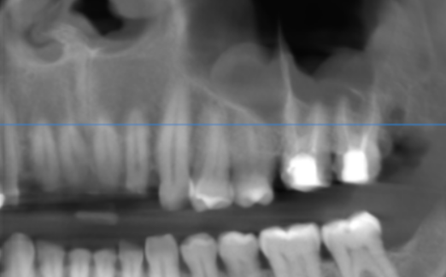

RECONSTRUCTED PANORAMIC VIEW

Left maxillary sinus

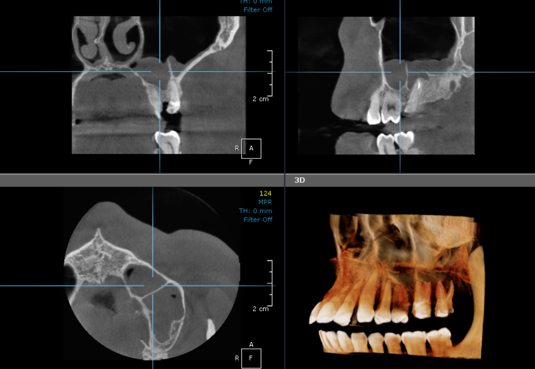

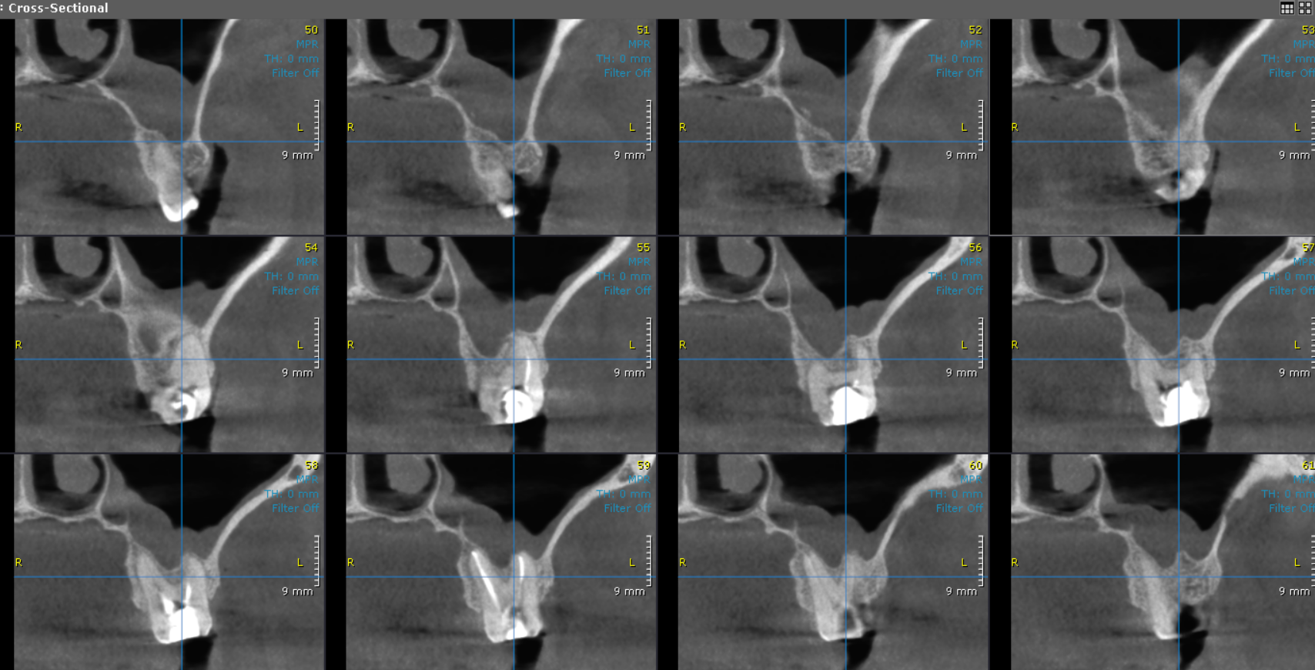
CROSS SECTIONAL VIEW

SAGITTAL VIEW

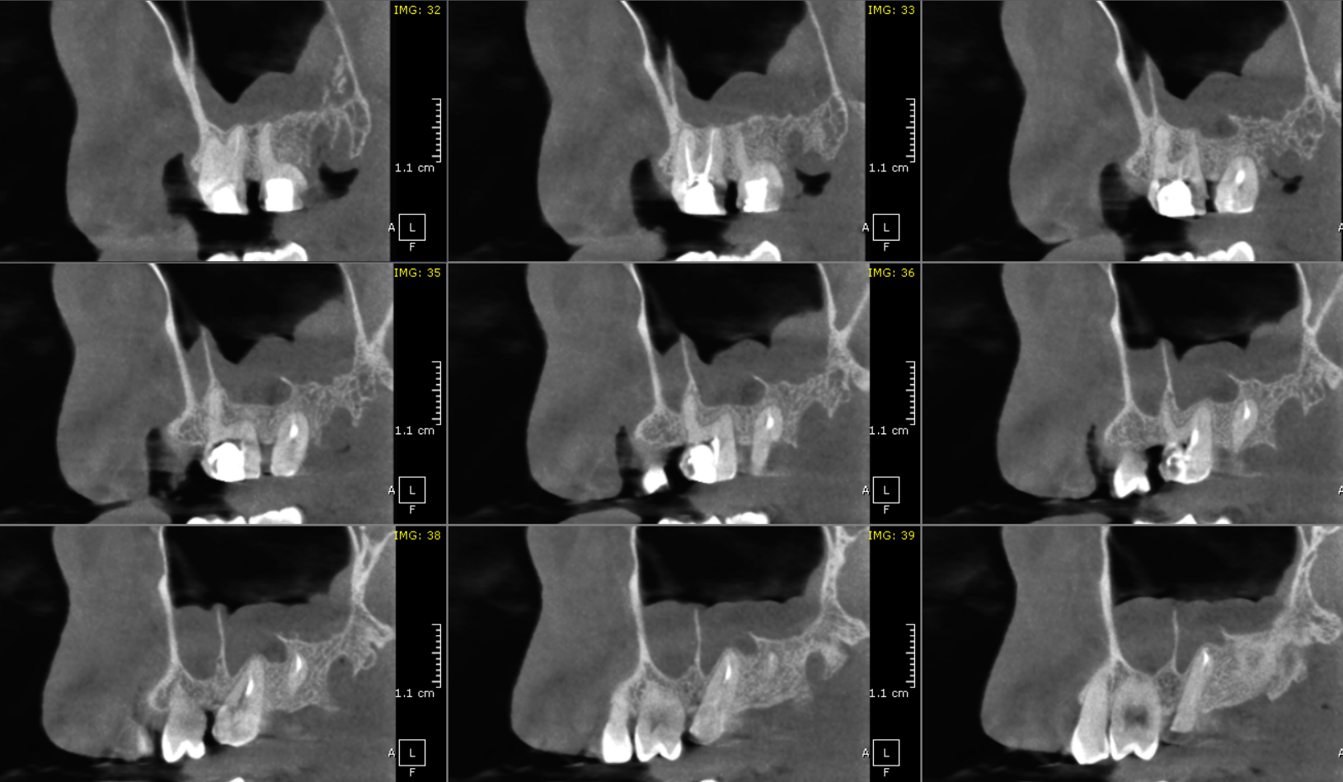

**** End of report ****

